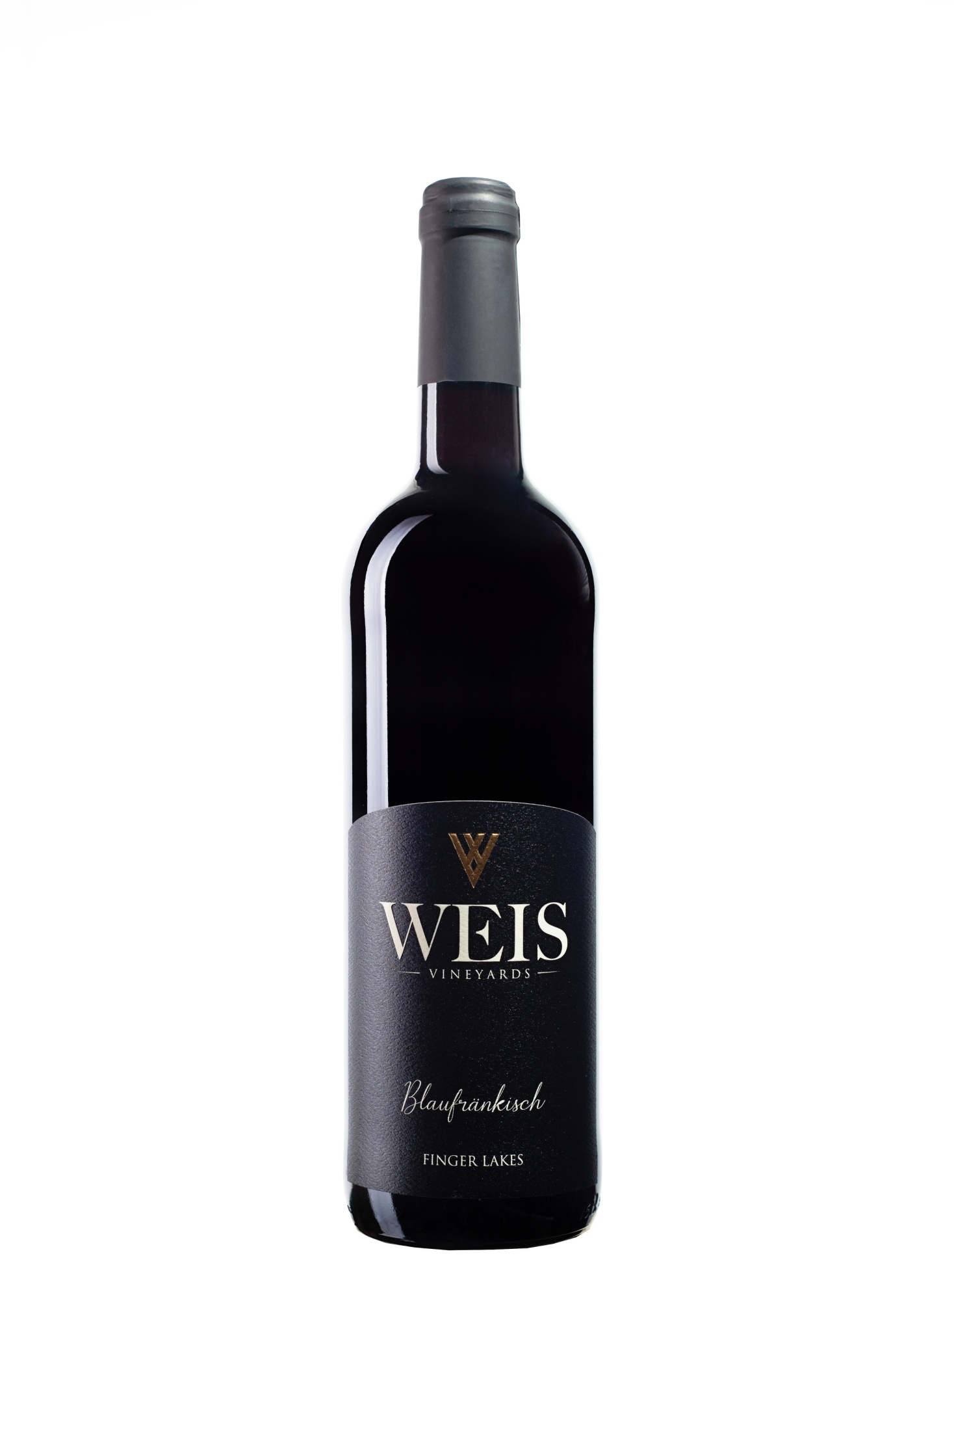

2019 Blaufränkisch

**2019 VINTAGE**

2019 was a coolish vintage with Growing Degree Days down 9% from a ten year average.  Since May was cold and wet budbreak and bloom were delayed.  The summer months were close to normal for heat accumulation with July being especially dry & sunny.  Overall the fall was somewhat cooler than average, but a wonderfully dry and sunny September brought ripening forward. Red wines have considerably more tannin structure. The colors are intense, the fruit crunchy and wines that have completed malo-lactic conversion discernably more accessible. A dry and sunny September has paved the way to wines that are ripe, yet restrained, with the reserved fruit and structure for cellaring.

**WINEMAKER NOTES**

The 2019 Blaufränkisch was aged for 12 months in French oak averaging three years in age. Solid in the mid-palate, this showcases beautiful and expressive fruit with darker flavors like plums. The expressive fruit is clearly the signature of this wine. It's pretty delicious, as well as enlivening, a nice choice for a lighter-styled summer red that you can drink a touch cooler than normal.

**TECHNICAL NOTES ACCOLADES**

100% Blaufränkisch 90 Beverage Testing Institute

Finger Lakes AVA

Alc: 12.5%

RS: 0.2 g/L

TA:

**UPC**

55052 00720