

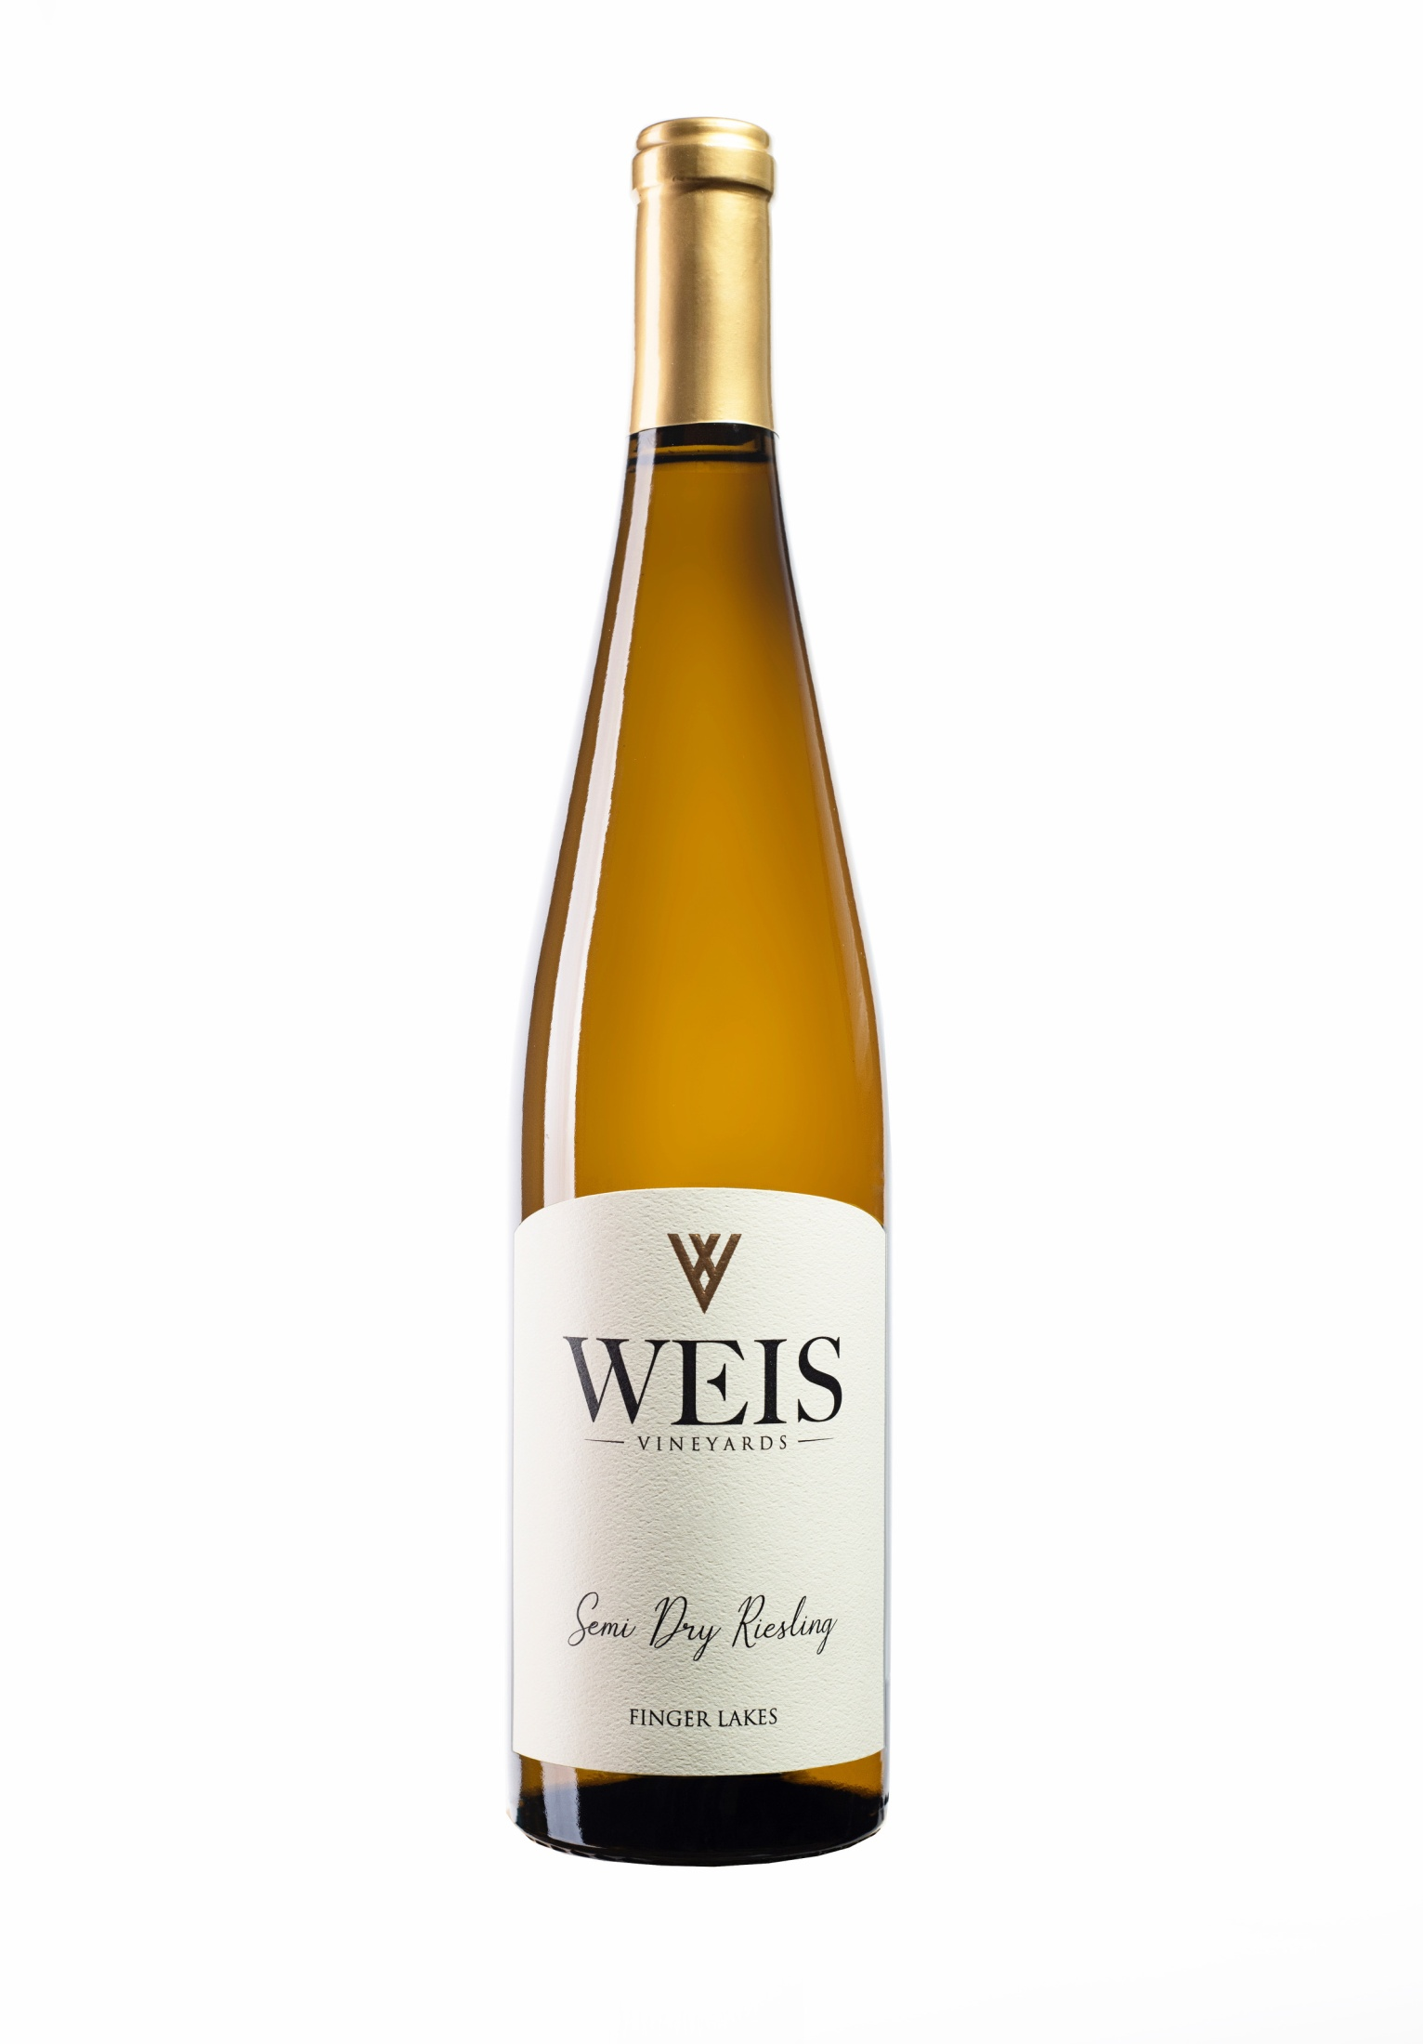

2019 Semi Dry Riesling

**2019 VINTAGE**

2019 was a coolish vintage with Growing Degree Days down 9% from a ten year average.  Since May was cold and wet budbreak and bloom were delayed.  The summer months were close to normal for heat accumulation with July being especially dry & sunny.  Overall the fall was somewhat cooler than average, but a wonderfully dry and sunny September brought ripening forward. White wines exhibit the freshness of a cool vintage. Rieslings are generally tight, minerally with more citrus fruit. The wines have good weight and will cellar very well. Wines that have been longer on lees have broader mouth feel and palate weight.

**WINEMAKER NOTES**

Pretty aromas of apple, peach and white blossoms meld with a lifted citrus backdrop in this semidry wine. It's rounded and juicy in feel on the palate, with bright orchard fruit flavors shot against sunny acidity. There's good drive and length, with a zesty, mouthwatering finish that leaves you coming back for more.

**TECHNICAL NOTES ACCOLADES**

100% Riesling 93 Beverage Testing Institute

Finger Lakes AVA 91 Wine Enthusiast

Alc: 12.0%

RS: 1.7 g/L

TA:

**UPC**

55052 00710